Sore Throat

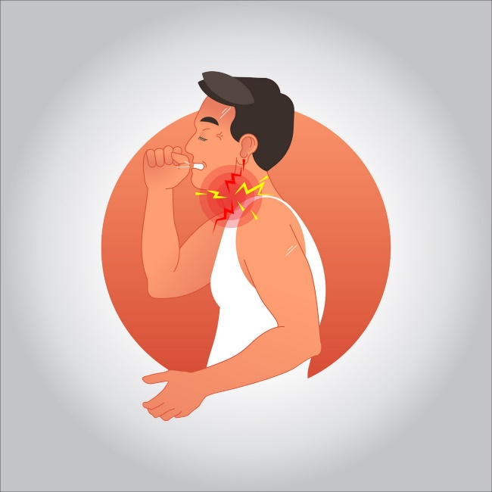

**A sore throat is pain, scratchiness or irritation of the throat that often worsens when you swallow. The most common cause of a sore throat is a viral infection, such as a cold or the flu. A sore throat caused by a virus resolves on its own.**

**Strep throat, a less common type of sore throat caused by bacteria, requires treatment with antibiotics to prevent complications.**

**Treatment**

**A sore throat caused by a viral infection usually lasts five to seven days and doesn’t require medical treatment.**

**To ease pain and fever, many people turn to acetaminophen (Tylenol, others) or other mild pain relievers.**

**Consider giving your child over-the-counter pain medications designed for infants or children, such as acetaminophen (Children’s Tylenol, FeverAll, others) or ibuprofen (Children’s Advil, Children’s Motrin, others), to ease symptoms.**

**Never give aspirin to children or teenagers because it has been linked to Reye’s syndrome, a rare but potentially life-threatening condition that causes swelling in the liver and brain.**

**Treating bacterial infections**

**If your or your child’s sore throat is caused by a bacterial infection, your doctor or pediatrician will prescribe antibiotics.**

**You or your child must take the full course of antibiotics as prescribed even if the symptoms are gone. Failure to take all of the medication as directed can result in the infection worsening or spreading to other parts of the body.**

**Not completing the full course of antibiotics to treat strep throat can increase a child’s risk of rheumatic fever or serious kidney inflammation.**

**Other treatments**

**If a sore throat is a symptom of a condition other than a viral or bacterial infection, other**

**Lifestyle and home remedies**

**Regardless of the cause of your sore throat, these at-home care strategies can help you ease your or your child’s symptoms:**

* **Rest.**
* **Drink fluids.**
* **Try comforting foods and beverage. Warm liquids — broth, caffeine-free tea or warm water with honey — and cold treats such as ice pops can soothe a sore throat.**
* **Gargle with saltwater.**
* **Humidify the air.**
* **Consider lozenges or hard candy.**
* **Avoid irritants. Keep your home free from cigarette smoke and cleaning products that can irritate the throat.**